Engineered for Beauty and Wellness

Relax FIR Sauna

at your home comfort

Sweat therapy:

Slim Effortlessly, Detoxify Naturally, Skin and Body care

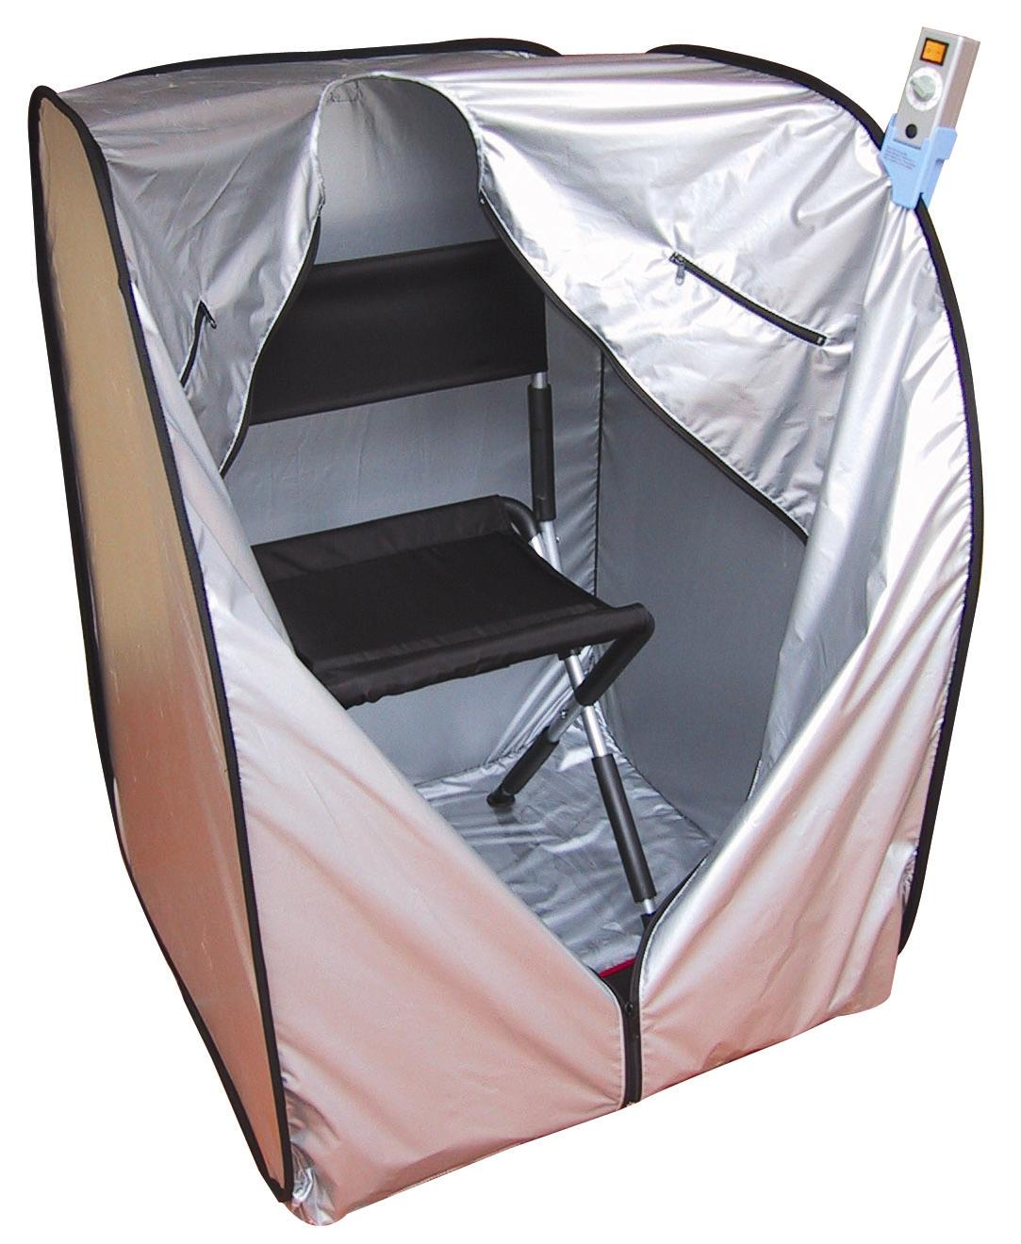
• Portable and easy set up in 5
minutes

• No pre-heating needed and save time

• Even energy produce

• Improves blood circulation

• Promotes cellular renewal

• Increases metabolism

• Induces profuse sweating

• For relaxation

• Burns calories without lactic acid
production
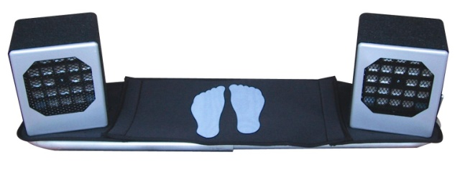
• Ideal for home use even in air-
conditioned environment
• Revolutionary ceramic semiconductor
technology
• Safe for people in all ages
• 1500W FIR Radiators
Auto-temperature controlled
40 ceramic semiconductors

Unique Features

- Specially designed cover with “FIR Energy Fan”

A specially designed cover plus ”Energy Fan” ensures that energy is evenly transfer within the sauna cover, as it feel like enjoying the hot spring both, without experiencing the same stuffiness or other discomforts.

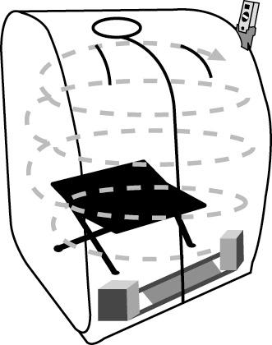
1.15m
0.80m
0.80m

• Even heat distribution, benefits comparable to a hot spring dip.
• Special reflective cover material and the FIR whirl ensure energy is evenly distributed in the cover. The body enjoys an experience similar to a hot spring bath.

- Easy to clean, as the cover does not stain and remains odour-free even after long periods of usage. This is unlike the traditional saunas that made of wood.

- The specially designed cover does not absorb ”direct heat energy” and there is no need to preheat or warm-up the equipment. Very convenient as compare to the wooden saunas.

• Use Relax FIR Sauna every morning for 15 minutes and it can help boost your body’s energy; just like having a jog.
• After work, use Relax FIR Sauna before bath for 15 minutes. Toxins accumulated in the body in the day will be eliminated. As relaxing as having a hot bath.

- The patented Energy source is the auto-temperature controlled Far Infrared Ray ceramic semiconductor, which does not cause burns, so it is 100% safe.

Relax Energy: Why It Is Special

Unlocking its Mystery and Following its Development:

Ceramic, as we know it, is used to make rice bowls or pots – it does not conduct electricity. However, with same modifications to the original structure of ceramic by adding or removing an electron from its molecular structure; equilibrium is destroyed and a semiconductor is formed. When electricity passes through the semiconductor, large resistance causes voltage to decrease and produce energy that changes into heat. It’s like a driver who brakes his car abruptly, not only will his car be slowed down, the tires will produce heat because of the large amount of friction between the tires and the road’s surface. The same line of reasoning applies to elements – after absorbing energy it will change into another matter. An example would be the light bulb. When electricity passes through the LED, it will change into light and heat.

History can attest to the benefits of Far Infrared Ray (FIR) Energy. The Japanese race, renowned for their longevity, is equally renowned for their passion for taking hot spring baths. Back in ancient Japan during the warring times, its injured warriors were often arranged to take hot spring baths after every battle to help heal wounds. Scientific research has confirmed the presence of many minerals in hot springs to which some after absorbing heat (energy) from the earth will produce energy that is compatible with the human body. This energy (FIR) at 4-14 microns helps activate cellular renewal, stimulate blood circulation and promote healing.

RELAX Energy
Voltage 120V

Ceramic Semiconductor

Relax ceramic semiconductor is a special technology – it excludes both near and medium infrared rays harmful to the human body, leaving behind only beneficial FIR at 4-14 microns. Relax FIR energy products not only benefit the user without causing burns but can also be used for long periods of time as well.

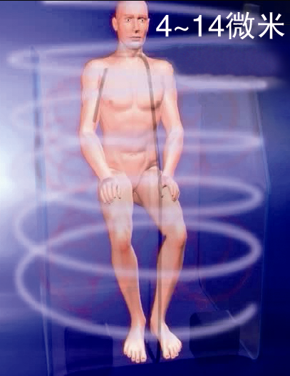
Vital Energy for Healthy Living
4-14 Microns

Jogging or footrace is good exercise and can improve the function of the sweat gland.

Qigong is an ancient art from the Chinese practice to maintain good health. It advances microcirculation in the body.

The Relax FIR Sauna device is ideal for busy people as it takes but fifteen minutes everyday to obtain the same benefits as jogging or practicing Qigong.

The Relax FIR Sauna cover is coated with a unique reflecting material. Together with a specially designed “whirlwind heater fan”, it employs the most efficient method of producing for infrared ray energy that spreads evenly in the chamber; energy is easily absorbed and internalized by the body.

The produced wavelength of energy is mainly 4-14 microns and is entirely compatible with the human body thus the body’s ability to conduct and absorb the energy. The skin will not burn even after a long stay inside the chamber ( Big power 1500w ); absolutely safe.

When energy is insufficient, energy cannot reach the depths of our body.
FIR Energy
But when energy is enough, this problem ceases to exist.
A powerful energy source is needed so as to reach the depths of the body because of the billions of water molecules that are in a row. Relax Energy Sauna is designed with an out put of 1500W and have power to deep activate 6 trillions cells in human body.
Energy is sufficient (1500W)
FIR Energy
Energy is insufficient

Through the resonance and absorption by water molecules, protein, and organic molecules, the body is able to conduct FIR Energy which is then absorbed by our cells and internal organs. Once energy is enough, it can be transmitted into the deeper parts of the body.

Improved Blood Circulation • Metabolism • Cellular Renewal

The continuous supply of far infrared energy in Life Energy Sauna can narrow the molecular angle and reduce the size of water molecules (clusters); resonant absorption by the body’s water molecules, protein, and organic molecules energizes the body’s internal molecules and helps dilate blood vessels. Given that blood vessels are now dilated and water molecules (clusters) in the body are also reduced, blood circulation is much smoother.

When blood vessels are unblocked, blood pressure will not increase. Blood vessels now have better elasticity and can better prevent the possibility of vascular sclerosis (hardening of blood vessels). Incidence of cardiovascular disease(s) will also decrease.

Once blood flow is smooth, it can flow throughout the blood capillaries of the whole body effectively and ensure a sufficient supply of nutrition; our metabolic rate will also increase. Muscles and skin regain elasticity and maintain the suppleness of youth.

The elderly suffer from poor blood circulation and other chronic diseases because nutrition cannot be delivered to their cells effectively and toxins cannot be eliminated. This speeds up the cellular ageing process; cells die faster. If toxins accumulate inside the body for long periods, the subcutaneous vessels shrink due to long-term air conditioning and the inadequate absorption of nutrients. This results in the blockage of pores and the skin loses its elasticity. Perspiration can help detoxify which is where Relax FIR Sauna comes in. Conventional saunas on the market may be beneficial but pricey while cheaper alternatives do not necessarily bring good results. Relax FIR Sauna on the other hand can satisfy the masses with its competitive pricing and superb results.
FIR Energy reduces the size of water molecules and helps dilate blood vessels and increases blood flow.
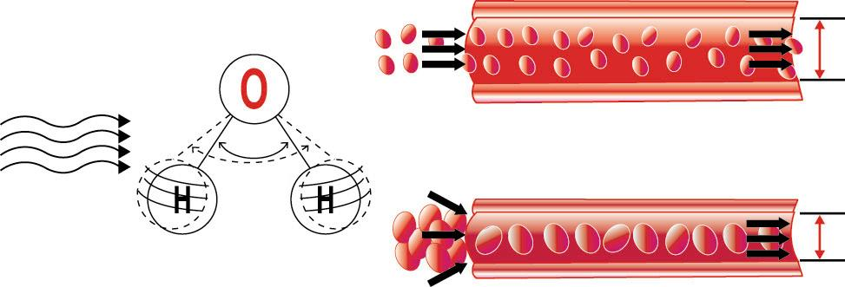
Far Infrared Ray Energy
Vibration
angle
Vibration of Water Molecules
Vasodilatation
When big molecules flow within small blood vessels, that would cause slow circulation and the blockage of vessels
1595cm (6.27 microns)
Without
Vasodilatation

Relax FIR Sauna is useful in slowing down the aging process; helps lose weight and improve skin condition. Eliminates body toxins as well as help prevent and eliminate chronic illnesses.

Anti-aging

• Life Energy Sauna makes water molecules in our body vibrated more vigorously. This increases blood circulation, so cells can get nutrition and oxygen more easily and eliminate toxins. During the warring times, the Japanese always had a hot spring bath after each battle. Hot springs can help wounds heal faster and better. This is the best evidence that FIR Energy helps (re)activate cells.
• Relax FIR Sauna allows blood vessels to dilate and open skin pores. This helps to relax the body and the mind.
• The dilation of blood vessels helps in improving blood circulation and eliminates toxins. Cells can also get enough nutrition; muscles and the skin regain their elasticity. Wrinkles are prevented and the skin has more lusters.
• Relax FIR Sauna also improves capillary circulation, and removes excess toxins from the body thereby reduces burden on kidney, helping to prevent kidney failure.
Beauty and detoxification

Relax FIR Sauna is excellent for increasing blood circulation to the skin, which is essential for beautiful, youthful, glowing skin. The result is a new “inner glow” as the skin is free of accumulated dirt and dry skin cells, due to deep cleansing of impurities. FIR improves the conditions of acne, eczema, psoriasis, burns and any skin lesions and cuts. Open wounds heal quicker with reduced scarring. FIR removes roughness, firms and improves skin tone and elasticity.

Cellulite is a gel-like substance made up of fat, water and waste, which are trapped in pockets below the skin. A Relax FIR Sauna can assist this condition, as profuse sweating helps clear this form of unwanted debris from the body. European beauty specialists confirm that a sauna will greatly speed any anti-cellulite program. Due to a deeper heat penetration into cellulite combined with more effective heating in these tissues, FIR Relax Sauna is significantly more effective than any conventional sauna.

The ideal PH for body fluid, which is around 7.4, which is slightly alkaline. Why does the human body’s PH change from alkaline (during childhood) to acidity (in adulthood)? This is because acids are not completely discharged from our system. Relax FIR Sauna can help to discharge the body’s toxins and acids through our skin pores. Relax FIR Sauna helps clean the body’s system and bring about better health.
Relaxation
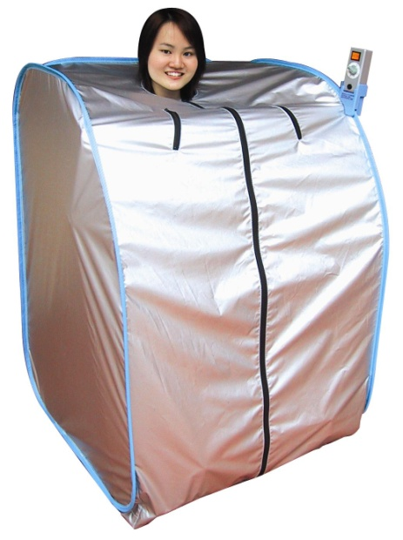
Discharge of lactic acid through profuse sweating helps relax muscles. Lactic acid is one of the causes of tiredness and aging of tissues. Life Energy Sauna delivers benefits of regular physical exercise without production of lactic acid and on top of that gets rid of lactic acid in our body. Accumulation of lactic acid results in chronic fatigue over time. Regular use of Relax FIR Sauna eliminates lactic acids, avoids accumulation and prevents premature degeneration of muscle tissues.

Slimming and overall improved appearance

Gravitational force and water retention in the body cause muscle mass and organs to slack and skin to lose its elasticity. This causes poor blood circulation and excessive fat accumulation. This is the corpulent reason for the swelling of waist, belly and eyelids. Relax FIR Sauna can help to discharge excessive water in the body and is a very useful tool for maintaining firmness and body shape.

Outstanding Caloric Consumption and Weight Control

In Guyton’s Textbook of Medical Physiology, we find that producing one gram of sweat requires 0.568 kcal. He Journal of American Medical Association (JAMA) states, “A moderately conditioned person can easily sweat off 500 grams in a sauna, consuming nearly 300kcal, which is equivalent to running 2~3 miles. A heat-conditioned person can sweat off 600~800 kcal with no adverse effects. While the weight of the loss can be regained by drinking water, the calories consumed will not be.” Relax FIR Sauna helps generate two or three times the sweat produced in a conventional sauna, the implications for increased caloric consumption are quite impressive. Relax FIR Sauna can, thus, play a pivotal role in both weight control and cardiovascular conditioning. This would be very valuable for those who don’t exercise and those who can’t exercise yet want an effective weight control and fitness maintenance program and the benefits of regular exercise.
Amazing! Relax FIR Sauna reduces body fat.

Consumes calories and burns fat in just 15 minutes.

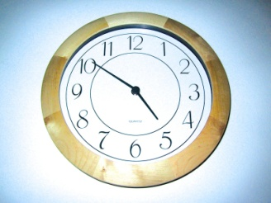
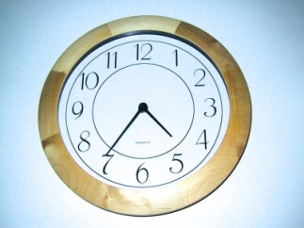
Start: End:
15 minutes

Relax and Enjoy
Relax Waterless “Hotspring”
Profuse Sweating
Powerful yet comfortable
Weight and body fat readings:
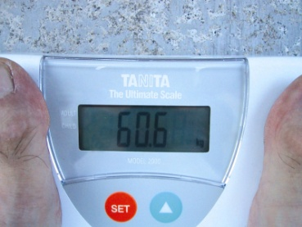
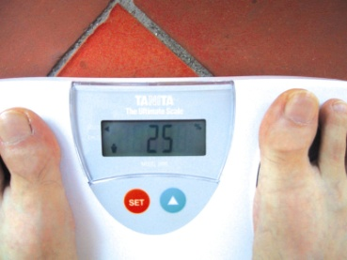

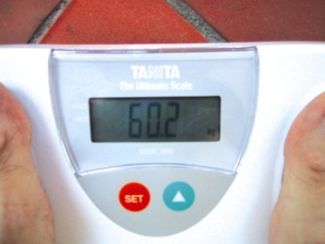
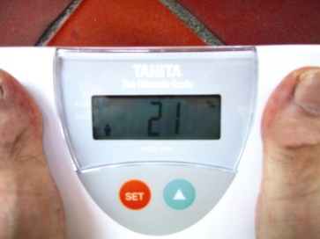
Before:
0.4 kg
Why?
4%

After:

Prevention of Chronic Diseases

A sedentary life style, over eating and lack of physical exercise are identified as reasons for obesity, diabetes, heart disease, hypertension and stroke. In many developed countries obesity and being over weight are among the top five enemies to good health and are responsible for about 55 percent of deaths, according to World Health Organization. On the other hand, more and more people in the developing world (such as India, China and Brazil) are suffering from obesity and related chronic diseases, which was associated mainly with the rich and developed world since a few decades ago. Increased urbanization, sudden change in diet, combined with a sedentary lifestyle, plays a large part in this change, as pointed out by WHO Expert Report 2003. Obesity can cause, among other things, coronary heart disease, diabetes, certain forms of cancer and arthritis. Relax FIR Sauna can play a pivotal role in the prevention and health maintenance of chronic disease by weight control and cardiovascular conditioning.

Prevention of Abnormal Cells Growth

Toxic substances accumulate in our body due to free radicals. Examples include insecticides (used on fruits and vegetables), antibiotics (in poultry) and antiseptics (used on other foods) etc. The best way to prevent abnormal cell growth is to detoxify through perspiration. The human body has a self-healing ability. But its self-healing ability is dependent on the healthy cellular function with sufficient nutrition and effective detoxification. FIR energy improves blood circulation and with sufficient nutrients and oxygen, there will be growth and cell reactivation, overcoming and preventing grow of abnormal cells.

“Detoxify or Die” – Restoring Total Wellness and Natural Healing Power

Dr Sherry Rogers, a leading environmental medicine authority out lines the scope of chemical pollution in our bodies in her book “Detoxify or Die” and shows in detail how to prevent disease and treat chemical overload. She wrote “…the far infrared sauna is far safer and infinitely more tolerable, because it uses a heat energy that penetrate tissues, triggering mobilization of chemicals from subcutaneous fat storage, directly into sweat” and “between 4 to 14 microns in the FIR spectrum, fall most of the rays that are the safest most vital to health and healing.”

Reduction of Blood Glucose Level

Viscous blood due to excessive blood glucose slow down blood flow increases blood pressure and prevents the absorption of nutrients by the body’s cells. In the long-term, viscous blood could cause eye complications, kidney problems, heart diseases and stroke.

Studies have shown that regular exercise lowers blood sugar by speeding the transport of glucose in the cells and is known as “invisible insulin”. Regular exercise make cells more receptive to glucose and decreases the sugar circulating in our blood stream.

Relax FIR Sauna is excellent in burning calories and produces the effect of cardiovascular conditioning, the positive results of physical exercise. Furthermore, Relax FIR Sauna provides FIR energy, which helps reduce the size of water molecule clusters and decrease the possibility of blood coagulation, thus blood flow is smooth. Long-term usage can help to reduce the problems of viscous blood.

Reduction of Uric Acid Through Sweat

Gout is a very painful inflammatory arthritis caused by uric acid crystals forming in the joints. Supersaturated uric acid in the urine can crystallize to form kidney stones that may block the tubes that lead from the kidneys to the bladder.

Heavy uric acids build up and using the Relax FIR Sauna may relieve gout. It is believed that urea and uric acid can be released more easily and frequently through sweating. It is also believed that only the Relax FIR Sauna can easily, conveniently and efficiently help the human body to release surplus uric acid without producing uric acid (as is the case in prolong exercise), and thus not causing a burden to the kidney.

It is suggested that when using the Relax FIR Energy Sauna, to drink a lot of water and eat alkaline food (green vegetables, sprouts and low sugar fruits) would be helpful for those who suffer from having excess uric acid in their system (or gout).

Exercise of Blood Vessels

Organs and blood vessels will degenerate if they are not actively functioning.

Relax FIR Sauna increases blood flow and dilate blood vessels. It also helps retain the elasticity of blood vessels and helps it to “exercise”.

When blood flow increases, waste, cholesterol and fat etc, will be removed from the wall of blood vessels. Once these cumulative materials are removed, blood capillaries of the brain cease to be blocked and apoplexy can be prevented.

The dilation or exercising of blood vessels can help prevent their degeneration. In cold climate, the blood vessels will shrink and become smaller in order to keep warm. Due to the regular demand of blood flow by the body, blood pressure must go up to maintain this flow. And this might lead to a breakdown of the blood vessels, causing hemorrhaging (thereby apoplexy).

Exercise can induce the blood current to move faster and dilate the blood vessels as well as increase the elasticity of vessels. But most people lack the time and patience to exercise everyday. The occasional exercise is not effective because the training and improving of elasticity of the blood vessels is daily work.

Relax FIR Sauna can help our blood vessels dilate as exercise can.

Relax FIR Sauna produces FIR energy which goes deep into our body, to the depths of the bone marrow. People with conditions such as heart diseases and high blood pressure show marked improvement after sing Relax FIR Sauna because FIR energy helps dilate their blood vessels and increase blood flow thereby unblocking and eliminating waste in the blood vessels. The opening of pores during perspiration also helps eliminate waste, toxins and fat inside the blood vessels.

Relax FIR Sauna is easy and convenient to use. It is a “waterless” hot spring. The even distribution of energy ensures maximum benefits. Enjoy the comforts of a hot spring dip right at home today!

CERTIFICATE:
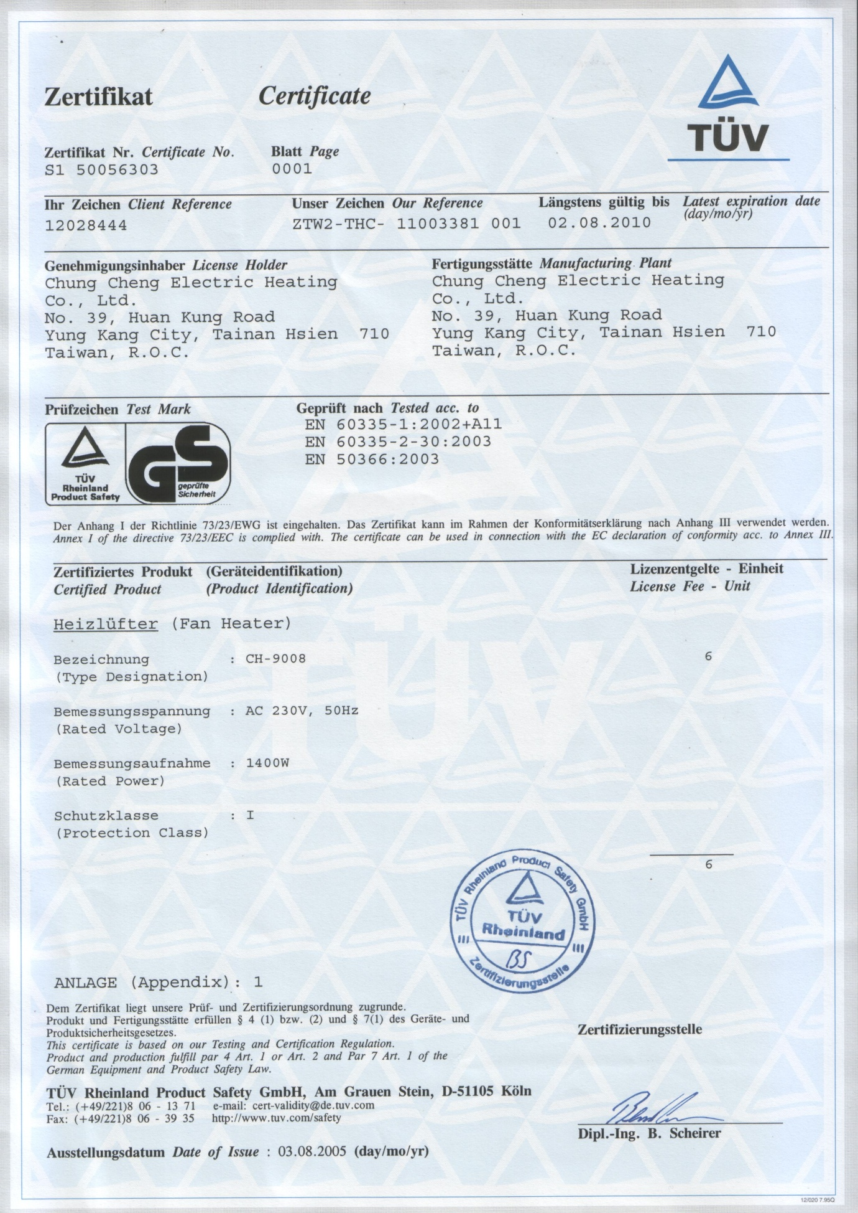
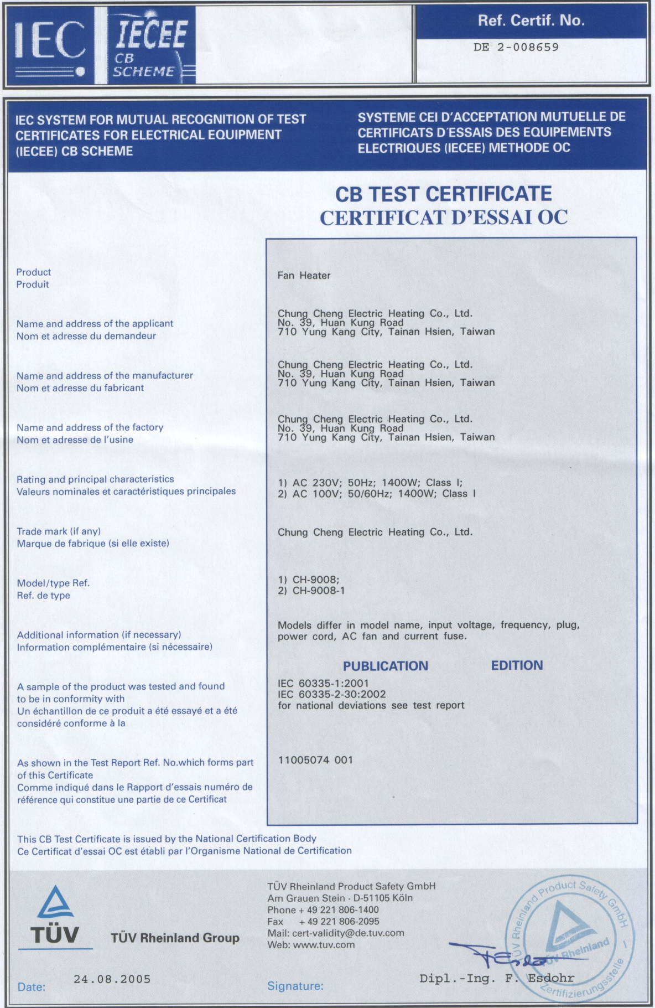
German
GS Certificate
CB test Certificate
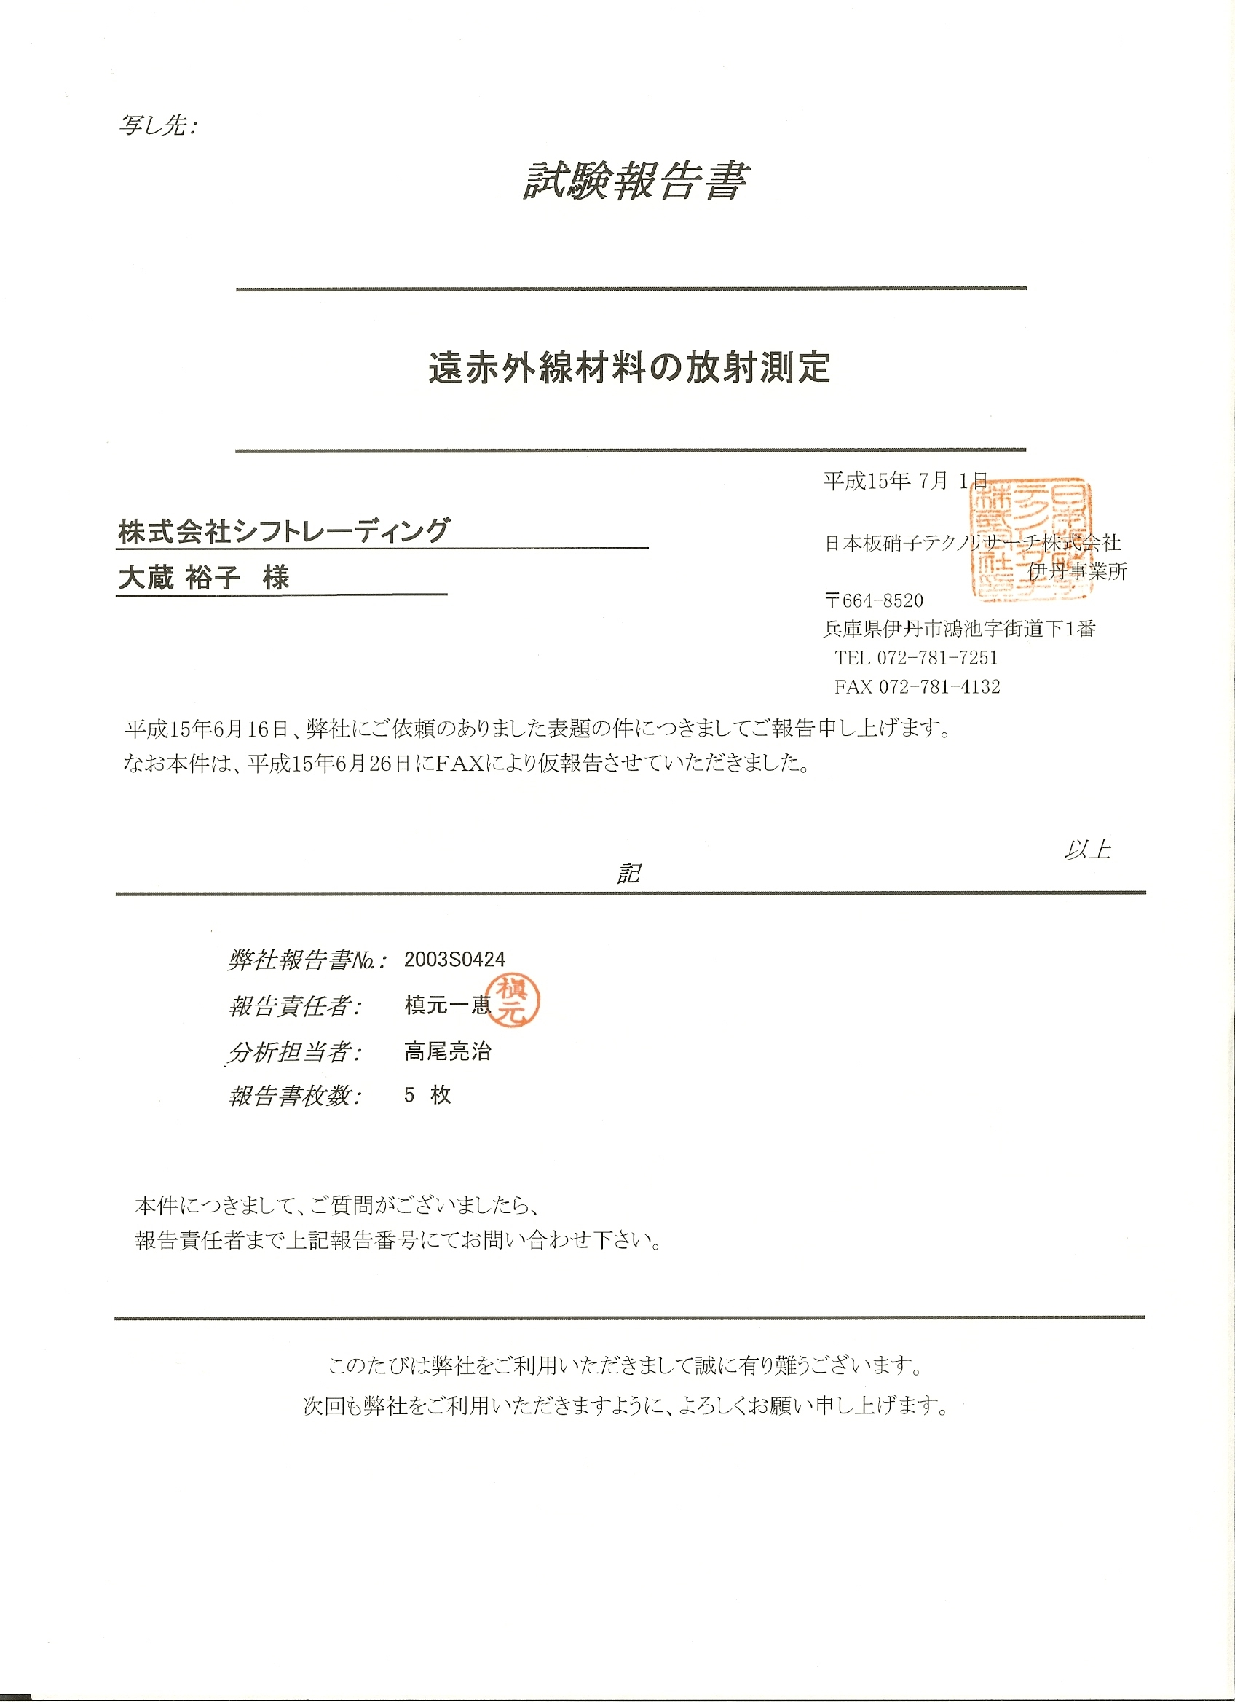

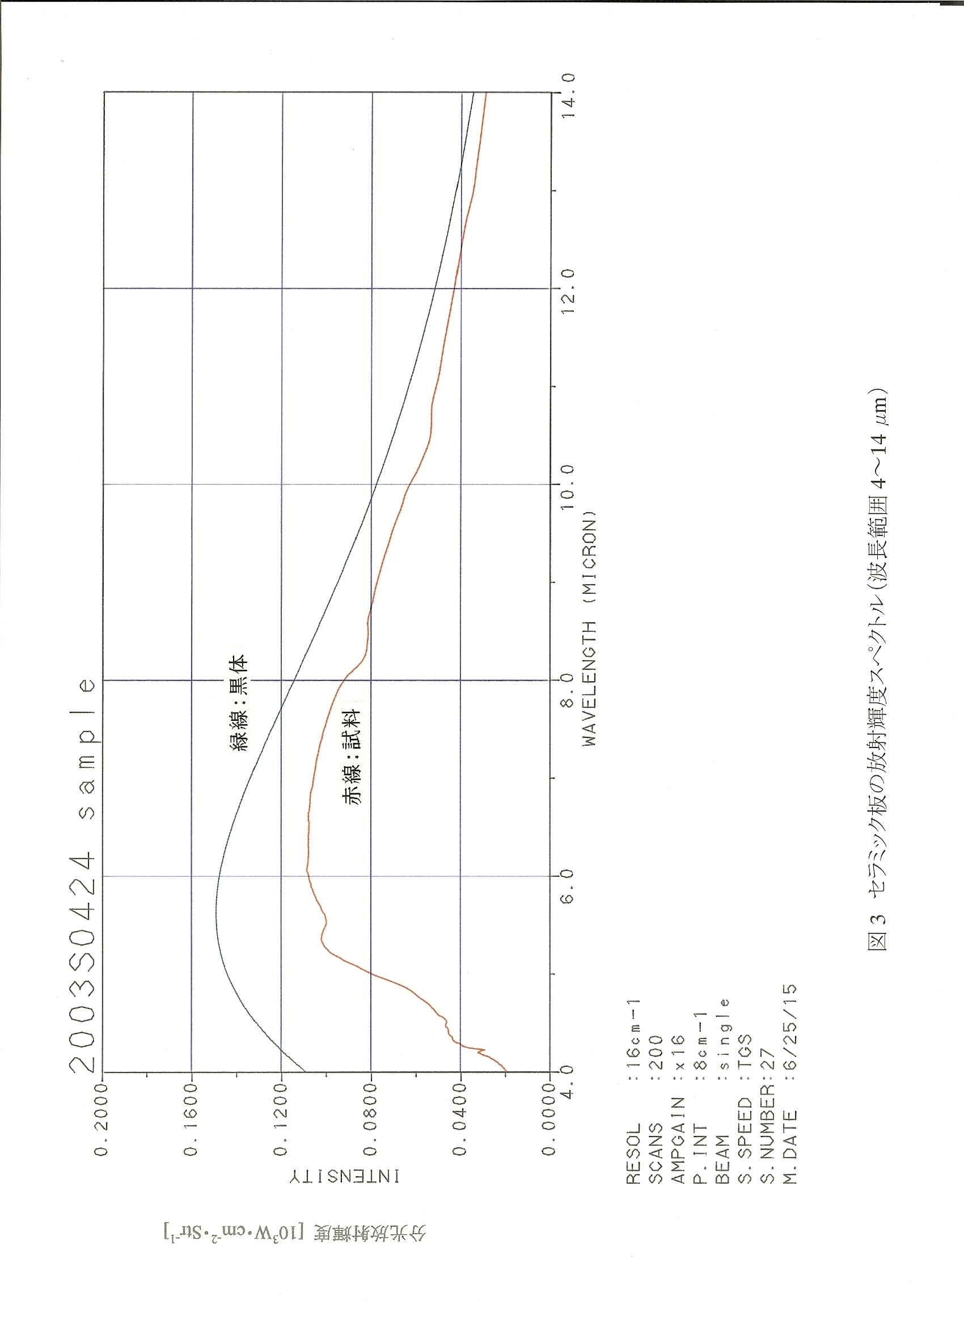
Japan
FIR Test Certificate
Japan
FIR Test Certificate -1
Specifications
Power Requirement  Power Output  Radiators | 110~120V, 50Hz  1500W ± 10%  20 Ceramic Semiconductors and 1fan for each radiator heater
Size of Reflective Cover (Erected)  Weight of Reflective Cover  Weight of Foldable Chair  (for max. weight of 100kg)  Weight of 2 Radiators  (c/w base frame. Cables and controller) | 0.8m (w) x 0.8m (d) x 1.15m (h)  1.8 kg  3.6 kg  6.4 kg
Size of package  Weight of package  Shipping 20 ft container | 0.69m (w) x 0.30m (d) x 0.56m (h)  14.5kg  250packages

The specifications can be changed without notice.

This product conforms both CE ( Standard of European Union ) and GS ( German Equipment Safety Law ) Standard.

Patented Products

PTC Heater FIR Sauna
Us Patent 5,125,070 6,615,419 B1
Germany patent 41 04 521 202 13 147.5

Energy Immunology by FIR 4-14um with patented Ceramic Semiconductor Technology
International Invention Awards • Worldwide Patents • Quality & Safety Standards

Relax FIR sauna FAQs

A. Technology, Safety

- Is FIR a harmful form of radiation? Will use the Personal Sauna cause any side effects?

The most basic and crucial difference between far infrared rays (FIR) and harmful rays is that virtually all living life have the need for FIR – warming energy. And all living life that metabolize release FIR. The sun’s rays include FIR that is needed by all living things but its rays also contain the harmful X-rays, UV rays and near infrared rays. Prolonged exposure can lead to sunburns and the peeling of skin. The Personalized Sauna has been designed to have only far infrared rays at 4 ~ 14 microns (1 micron = 1/1000 mm). By (water) molecular vibration and resonant absorption, energy is transmitted deep into the body and reaches the bone marrow. Thus, the Personalized Sauna provides energy that you can easily absorb without having to worry about the side effects.

- Will my skin dry? Will I suffer from burns?

Only a wavelength that is less than 3 microns (e.g. near infrared rays, UV etc.), which stops at the skin’s surface and cannot be absorbed by us can cause scalding. And in serious cases, burns might result. Through the resonance and absorption by water molecules, protein, and organic molecules, the body is able to conduct FIR energy at 4 ~ 14 microns which is then absorbed by our cells and internal organs. This energy is then transmitted into the deeper parts of our body, thus eliminating the possibility of burns.

Because the process of perspiration and detoxification involves losing a large amount of water, the body needs to be constantly replenished with water before and after one uses the Personalized Sauna and the FIR Lamp. This helps to prevent the possibility of dehydration.

- What is the difference between Personalized Sauna and others on the market? Looks the same to me.
 | Personalized Sauna | Wooden Sauna | Steam Sauna | Electric Sauna
Pre-heating | None | For 15 ~ 30 minutes | • Need for water to boil  • About 15  minutes | None
Temperature | • Even  • Similar to Traditional saunas  • “Waterless hot spring” energy | Even | • Uneven  • Hot steam  rises, the feet  does not feel  the heat | • Uneven  • It irradiates only certain parts of the body  - 2 or 3 pieces of electric pads
Benefits | 1500W big power and low temperature, can reach the depths of the body and activate sweat glands | Satisfactory | • Not effective  •  • High humidity;  unable to effectively perspire | • Acceptable  • Uneven  irradiation  cannot bring  obvious benefits
Maintenance | Wipe to keep clean | • The wood retains moisture and has an odour after a long usage period  • Difficult to  clean | Needs to be washed every time after use | Difficult to clean because the heat sources are attached to the cover
Size | Moderate, comfortable, collapsible & portable | Large | Moderate | Small, claustrophobic

B. Home use

- Will my electricity bill increase drastically if I use the Personalized Sauna everyday?

Because of the little time involved every time you use the sauna, it consumes much less electricity than the average refrigerator or air-conditioner. A 15 minutes session costs around USD 25 cents. The Personalized Sauna is suitable for the entire family and helps to keep all in good health.

- Can I use the Personalized Sauna everyday? And how long for each session?

Absolutely. In fact, the Personalized Sauna is designed for everyday use. In general, most people do not have the habit of exercising regularly. The Personalized Sauna can help to reverse this sort of unhealthy lifestyle. The skin is our biggest detoxification tool. A 15 minutes session daily effectively purges accumulated toxins and waste matter from the body and helps to keep it ‘clean’. Blood circulation is improved, cells activity stimulated and fatigue relieved. Effectively reduces the risk of chronic illnesses such as high blood pressure, heart problems and diabetes etc.

- How do I clean the sauna after use? Will my perspiration cause the sauna to smell?

Maintenance is easy. Simply use a slightly damp cloth to wipe the radiators and the interior of the sauna cover. The footpad between the two radiators can be removed and washed if necessary. But because the titanium oxide coated-ceramic semiconductors are anti-bacteria, all you need to do is switch the sauna on for 2 ~ 5 minutes after use each time to help remove any unpleasant smells. (Do not attempt to clean the sauna with any strong cleaning agents.)

- Can I shower immediately after using the sauna?

Yes you can. Wipe dry and take a short rest before stepping into the shower. Through molecular resonant vibration and absorption, FIR energy is not concentrated on the surface of the skin. The body is kept warm internally, cold air cannot enter the pores thus it is unlikely that you will catch a chill.

- The Personalized Sauna is really big! It will take up too much space. My home is really small.

The Personalized Sauna is both collapsible and foldable making it suitable for easy storage. Moreover, it serves as an ideal tool to help keep the whole family fit and healthy. On this account, space is not a big problem. It will benefit you and your family much more than the television or refrigerator can. Beside, it take less than 5 minutes to install or uninstall it.
`
C. Preventive Healthcare

- Why does the average man need to use the Personalized Sauna? What about people who exercise regularly? Do they have a need for it as well?

(1) Traditional Chinese medical (TCM) viewpoint: Helps stimulate blood circulation and reduce bruising. People who lack exercise suffer from poor blood circulation and are more prone to ischemia. People who have a high percentage of body fat suffer from poor blood circulation because the fat in their blood slows circulation. The body also becomes more prone to bruising when circulation is poor. Thus you need the sauna to help improve blood circulation.
(2) Regular exercisers: generally speaking, (a) exercise helps to strengthen both the muscles and bones and maintain their metabolism, (b) correct irregular heart beat and strengthen heart muscles and (c) improve lung activity. But physical exercise brings no evident benefits to the micro-circulation in the body’s organs. Exercise also builds up large amounts of lactic acid that can only be eliminated through the use of the Personalized Sauna.

Personalised Sauna vs. Exercise and Labour

Description | Manual Labor | Exercise (slow jog/quick walk) | Personalized Sauna
Muscle-Skeletal (Limbs) | • Induces load  • Lactic acid accumulation | • Induces load  • More lactic acid accumulation | • No load  • No lactic acid production
Heart, Lung | Of little benefit | Strengthens | Reduces heart load while strengthening lung function
Blood Circulation | Moderate improvement | Improvement | Improves micro and terminal circulation & organ function
Detoxification | N.A. | Little benefit; increases lactic acid accumulation | Deep warming effect induces large amounts of perspiration that effectively purges urinal, lactic acids & other toxins
Perspiration effect | Depending on individual; more so for certain areas | Depending on individual; of little use to people who cannot perspire; perspiration occurs at certain areas | Helps to open the sweat glands of those who have trouble perspiring; total perspiration; eliminates toxins through pores
Burning of calories | Little | 600 calories  (1 hr / 10 km) | 600 calories  (15 min)

D. Beauty, Slimming

- Does the Personalized Sauna help to slim?

The natural and healthy way to lose weight is to increase a person’s basal metabolic rate. Daily repeated usage (in and out) of the Personalized Sauna, with the effects of deep warming, it can help to increase a person’s metabolic rate. Coupled with healthy eating habits, it is not impossible to achieve an ideal weight and good health at the same time.

- I’m concerned that using the Personalized Sauna often will reduce my breasts (e.g. from a cup C to cup B), will that happen?

Under the pretext that you are using the Personalized Sauna for slimming purposes, it is more likely that you will experience a firming up of the bust line instead of breast reduction. A woman’s breasts consist largely of fats and different individuals experience weight loss at different parts of their body. However, it is unlikely that you will go from a cup C to B unless there is drastic weight loss.

- Can the Personalized Sauna ensure muscle elasticity?

Warming energy helps activate cellular renewal in the blood vessels (including capillaries), blood stream and muscles. This explains why regular usage helps to increase oxygen in the blood and provide a more youthful appearance to the skin. Supplement this with a suitable amount of exercise and you are on your way to attaining a more radiant and firmer complexion.

E. Effects

- I’m worried about the red spots that have appeared on my skin after I started using the Personalized Sauna. What causes them? And is it normal that it itches?

The occurrence of red spots and itchiness is perfectly normal in that it is only a transitional phase in the process of detoxification. When toxins are unable to be carried away by the body’s blood stream, they appear as red spots on the skin. Different individuals experience different symptoms and this sort of reaction does not necessarily occur after once or twice in the sauna. In fact, it might take weeks or even longer for anything like that to happen. Not everyone will experience these symptoms but even if you do, it is not a cause for worry. If your skin itches, avoid scratching. Instead, irradiate the afflicted area with the FIR Lamp to help stop the itch and prevent infection.

- I used to suffer from migraines and after I started using the Personalized Sauna and the FIR Lamp, this problem is starting to plague me again! I am very much distressed. Why has this happened?

The pain is a result of poor/restricted circulation in the head. Medication taken in the past did not eliminate the root cause of your discomfort but has numbed your nerves such that you no longer feel the pain. What the Personalized Sauna does is to improve overall blood circulation and activate cellular renewal thus helping you to recover from the numbing of senses. This is a transitional period and will pass quickly if you make use of the Personalized Sauna/FIR Lamp diligently. You will recover fully even without the help of medication when both qi (internal energy) and blood circulation improves.

- Is it normal to experience some Relaxedness after a sauna session?

FIR energy helps dilate the body’s blood vessels but because the quantity of blood remains unchanged, the head experiences a temporary lack of oxygen and blood thus explaining the passing Relaxedness. This is similar to how some people feel after exercise. Use the Personalized Sauna everyday to help the body in its process of ‘making’ blood and curb the problem of Relaxedness at its root cause. As for those who already suffer from ischemia (inadequate blood) or anemia (poor blood), lying down on your back and raising your legs can help induce blood flow backwards thereby relieving the problem of headaches.

- Why is it after using the Personalized Sauna I often feel both
hungry and sleepy?

Blood flow quantity increases, metabolic rate experiences a sudden surge and induced perspiration in the process of detoxification all contribute to the burning of both calories and nutrients. Helps relieve fatigue, reduce blood pressure and relax body muscles. It is at this point in time that you need to replenish on nutrients and gain adequate rest. First time users are more likely to experience hunger pangs immediately and a desire to sleep after several hours. Athletes experience a similar body change – after sports they feel both tired and sleepy.
However, after a period of time when the body has become accustomed to using the Personalized Sauna, with adequate nutrition, you should feel more energetic and experience better sleep in the long run.

- Why is it after/during the usage of the Personalized Sauna certain areas of the body feel more hot/painful than the rest of the body?

(1) Areas more affected than others are a result of poor oxygen and blood circulation in that particular part of the body. It could also be that of an old injury. (Refer to Q.20)
(2) Another common problem that afflicts many is pain, swelling and/or redness at the calves. It could be that you had placed your calves too close to the aluminum part of the chair while doing the sauna or that you had stood for the whole day and your calves are suffering from poor circulation. You should put your feet in between the two radiators. If redness and swelling persists, massage your calves with the RELAX massager (to improve local circulation) before entering the sauna for better results.

- Why is it I perspire less after I started using the Personalized Sauna? (Is cold weather a factor?)

(1) How much fluid you drink is a factor. When your body has little water in it, naturally perspiration amounts will lessen; cold weather is a factor because when temperatures are low, more energy is needed to help open the pores.
(2) Even if there is little/no perspiration, microcirculation in the body is being stimulated when you are in the Personalized Sauna, thus there is little cause for worry.
(3) We do not encourage you to use perspiration amounts as a gauge of the sauna’s effects. If the body’s internal circulation is improved upon, sweat will naturally occur.

- Why have my sleeping hours lessened after I started using the Personalized Sauna?

After you use the sauna each time, both your blood circulation and blood flow is made smooth and improved upon. As a result of this, you gain ample rest and a more peaceful sleep. This explains why you need lesser hours.

- Why do my old wounds hurt after I use the sauna?

FIR helps activate cellular renewal and heal wounds faster; blood flow is smoothed and blocked passages cleared. Blood circulation is naturally poorer at the old wounds which explains why you feel a prickling or itchy sensation there signaling restricted flow. Whenever pain is experienced, stop the sauna session and remember the duration taken. Do continue to use the sauna regularly with similar or slighter shorter duration. With patience, one should be able to gradually increase the duration of the sauna session with cellular renewal and healing.

F. Special Problems

- Will using the Personalized Sauna everyday adversely affect sperm production for the male?

The male reproductive organ does not produce sperms all the time (24 hours). A short 15 minutes usage will not affect a male’s ability to produce. Unlike the other traditional sauna, the Personalized Sauna produces the pure FIR energy, so it would not have those side effects that cost by regular high temperature.

- Are people fitted with heart pacers, rods in the legs etc. suitable to use the sauna?

These supplementary medical apparatus are wrapped around by muscle tissue. FIR energy penetrates the skin and goes deep into the body; improved blood circulation helps bring warming energy to all parts of the body and does not just concentrate on any particular area. As the body perspires during the detoxification process, body temperature decreases. The area where the (for e.g.) heart pacer is fitted is kept within a humanly tolerant temperature range. The basic rule when using any FIR product is not to employ it directly on the part of the body fitted with foreign objects. This helps to prevent the objects from reflecting and rejecting the warming energy.

G. Chronic Diseases

- How can sufferers of high blood pressure, heart problems, diabetes, depression, manic-depression, work-stress etc. benefit from using the Personalized Sauna?

(1) Hypertension – Circulation is the continuous flow of blood from the heart to the body and back to the heart again. It is the process that keeps you alive. Arteries are vessels that deliver oxygen-rich blood to your body. Veins in your body are vessels that return oxygen-poor blood to the heart. There are two types of blood pressure:
(a) Systolic Blood Pressure (SBP) is the pressure in the vessels when the heart is contracting or delivering blood out from the heart.
(b) Diastolic Blood Pressure (DBP) is the pressure in the vessels when the heart is expanding or collecting blood back to the heart. When both SBP and DBP are higher than the normal level, an indication that the body is not getting sufficient oxygen from the circulation, the heart has to pump (contract and expand) harder. This increases the burden of the heart. But if sufficient oxygen can be supplied though blood circulation, blood pressure will be normalized. Regular use of the Personalized Sauna improves blood circulation by vasodilation (expansion of blood vessels) and reduces the size of water molecule clusters (more than 90% of blood plasma is water). Deep, slow and long breathing during sauna sessions will also help to increase oxygen in the blood.
(2) From the traditional Chinese medicine (TCM)’s perspective, chronic diseases such as diabetes, depression, manic depression and work-related stress are caused by inadequate blood flow and nutrient deficiency. The basic effective solution is to ensure good blood circulation that delivers sufficient oxygen and nutrients to the body.

- How does the Personalized Sauna help sufferers of dialysis, uraemia (kidney disease), rheumatoid arthritis, joint aches, inter-vertebral disc protrusion related complications and osteophyte (small abnormal bony outgrowth) etc.?

(1) Our kidneys contain millions of nephrons (which consist of capillaries and tiny tubules) that function as filters to ‘clean’ our blood. For people with kidney disease or degenerated kidneys, the filtration capability is poor because the nephrons are damaged. They are advised to limit the intake of water. Personalized Sauna helps by excreting uric acid, urea and toxins through your perspiration. Increase your intake of water as you gradually increase the duration of your sauna sessions. Patience and endurance is necessary for long periods of therapy.
(2) Rheumatoid arthritis is caused mainly by the malfunctioning of the immune system (auto immune). Our body’s immune system can be strengthened and normalized by improving blood circulation and activating cellular function.
(3) Joint aches, disc protrusion complications and osteophytes are mainly caused by stiffening muscles or poor posture. For therapy, do consult a qualified chiropractor. But the Personalized Sauna does help to enhance your therapy sessions because it helps improve blood circulation and cellular function of both the muscles and bones.

- people undergoing chemotherapy and radiotherapy?

(1) It is important to understand the role of the Personalised Sauna in strengthening a person’s overall health (including the immune system) through effective detoxification. The Personalised Sauna is not meant to replace treatment and medical consultation and that cancer patients should seek the right treatment. However, it is likely that medical treatment will prove more beneficial if you sought to take good care of yourself first.
(2) Increased oxygen helps increase the growth of normal cells around the cancerous area. This is beneficial as it prohibits the spreading of cancer cells. The Personalised Sauna enhances oxygen delivery in the body including the cancerous area. Coupled with medical treatment, improvement can be expected.
(3) Massage the harder tissues on both sides of the vertebra to soften the areas. With a more activated central neural system, the use of the Personalised Sauna will help to show a more marked improvement.

